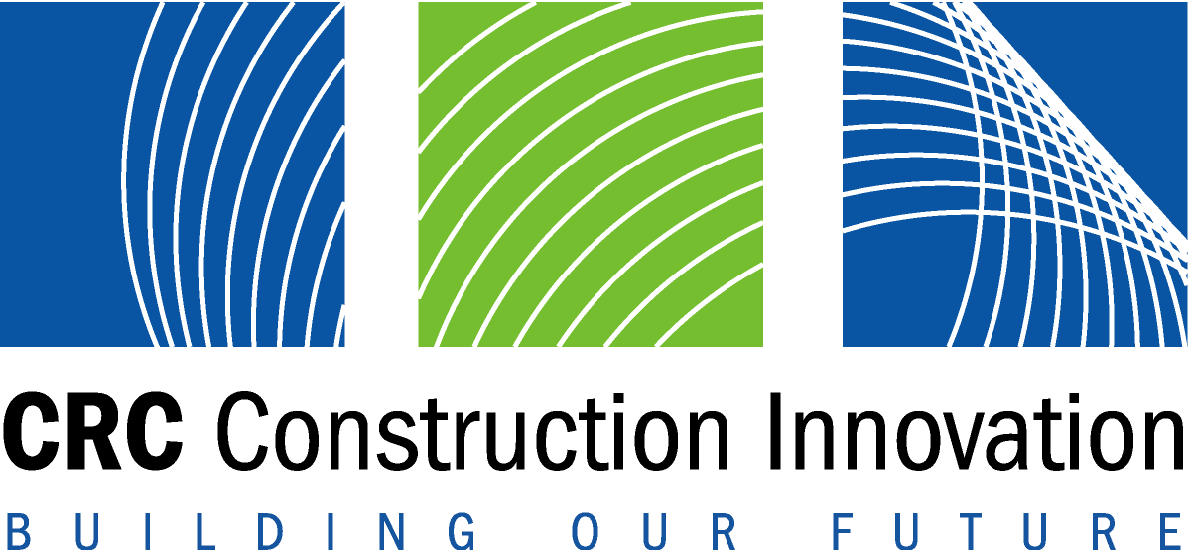


The BRITE Research Project of the

CRC for Construction Innovation

For immediate release Wednesday November 2, 2005

Queensland Deputy Premier Launches BRITE Innovation Case Studies
The Deputy Premier of Queensland, and Minister for State Development, Trade Innovation and Finance, the Hon Anna Bligh MP, launched the 2005 BRITE Innovation Case Studies of the building and construction industry in Brisbane on Wednesday 2 November, 2005.
The Department of State Development, Trade and Innovation is a partner in the CRC for Construction Innovation, and a contributor to the BRITE Project. The Deputy Premier said, “The Queensland Government is highly supportive of the CRC for Construction Innovation, which is helping us encourage a smarter state. The BRITE Project shows how all construction organisations can become more innovative, including SMEs and regional businesses.”
Innovation is widely seen as the key to better productivity and profitability. Increasing innovation in the building and construction industry, which employs more than 730,000 people in Australia, contributes to economic growth.
The BRITE Project is a research project of the Cooperative Research Centre for Construction Innovation, based at the Queensland University of Technology in Brisbane. The project’s aim is to increase the rate and quality of innovation in the industry.
Speakers at the launch were a mix of innovative contractors, consultants and clients, including:
- Michael Deare, Chief Executive, South Australian Cricket Association
- Max Smith, Deputy Director General – Works, Qld Dept of Public Works
- Diana Kureen, (former) Bushland Environment Officer, Hunters Hill Council
- Phillip Marsh, Director Marsh Civil Contractors
- Scott Bird, Managing Director ENV Australia
- Jeremy Harding, Business Development Manager, S-Squared Corporation
- Rebecca Hoskin, Manager Capital & Facilities, Dept of the Premier & Cabinet-Arts SA
- Collin Harvey, Director Ecoflex Australia.
The innovators described how they have overcome obstacles to innovation. The clients spoke about how they have encouraged innovation. All speakers shared the lessons learned on construction projects. The topics covered new contracting methods, water management, 3D CAD, toxic waste disposal, long span roofs, air conditioning and pavement technologies.
more…

Dr Karen Manley, Leader of the BRITE Project, said “The project has had a significant impact on industry culture – creating a ‘can do’ attitude to innovation. These new case studies show that both original innovation, and adoption of best practice, improve project and business performance.” The CEO of the CRC for Construction Innovation, Dr Keith Hampson has commended the case studies as “another way SME’s across Australia can learn to lead the way through smarter approaches to technology and business. Small and regional doesn’t necessarily translate into a disadvantage. We have shown through these case studies that Australian firms can mix it with the best .. and win! These are great lessons for our industry.”
Full details of all BRITE case studies can be found at www.brite.crcci.info

Contacts:

Michelle Coillet - (07) 3864 9146, or m.coillet@qut.edu.au
Dr Karen Manley – (07) 3864 1762, or k.manley@qut.edu.au

