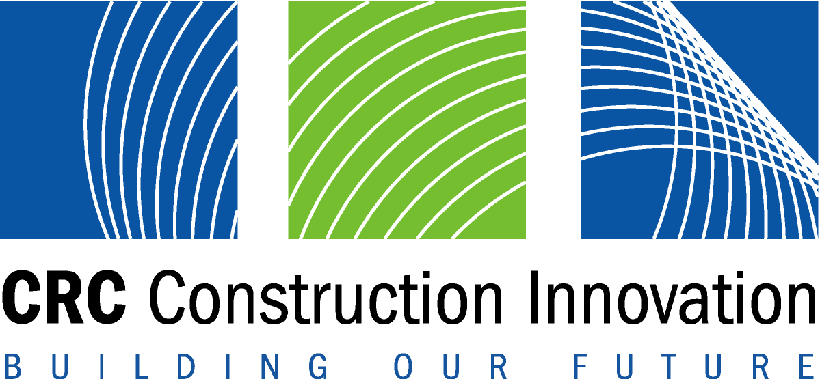
CRC for Construction Innovation
2004 International Conference
25th – 27th October 2004, Gold Coast

Embargo Wednesday October 27 Clients Driving Innovation

Sustainable knowledge society – a European approach

Beyond the Tower of Babel

Property managers borrow hospitality approach

Innovative approaches to new and serious challenges facing the construction industry will be addressed today at Clients Driving Innovation, an international conference hosted by the CRC for Construction Innovation.
“The construction industry currently provides 14 per cent of the nation’s wealth, employs 730 000 people, and has a significant impact on other industries,” Construction Innovation CEO, Dr Keith Hampson said.
“But challenges from globalisation, advances in technology, environmental factors and changes in the structure of the Australian economy need new approaches if the industry is to be competitive and capture new opportunities.”
Leading built environment practitioners and researchers from around the world will explore issues such as grasping client requirements, health and safety, electronic simulation, innovative asset management and international innovation.
“Most importantly, researchers and the users of research at an international level will have a chance to rub shoulders and chat over a beer,” Dr Hampson said.
“Researchers come away with a better grasp of the business pressures facing the sector, and people who use the research get an insight into the structure and drivers of research communities.”
Conference keynote Australian and international presenters will speak on the following topics:

Sustainable knowledge society – the European approach
Sustainable development is key factor in the transition to a knowledge economy, according to Mr Pekka Huovila from Finland’s VTT Building and Transport.
“A major priority of the European Union policies (EC 2002) is to become the most competitive and dynamic knowledge based economy in the world, capable of sustainable economic growth with more and better jobs and greater social cohesion by 2010,” said Mr Houvila who will speak at Clients Driving Innovation today.
“Our future sustainable knowledge societies will clearly be driven by social and cultural innovation as well as technological processes,” he said. “Sustainable development is at the heart of integrated policies for growth, employment, social cohesion and the environment.”
Mr Houvila will present two examples of innovative communities, including a self-organising European research and innovation community, and a living laboratory concept where public and private investments meet in a city environment to support sustainable businesses and improved wellbeing for individuals.
Contact: Mr Pekka Huovila, VTT Building and Transport on email: pekka.huovila@vtt.fi

Beyond the Tower of Babel
Construction clients and the project team often speak different ‘languages’ and can have different ideas of value, according to CSIRO Manufacture and Infrastructure researcher, Dr Greg Foliente.
“Misinterpretation is rife in the construction industry,” Dr Foliente said. “Project teams cannot accurately interpret a client’s needs and requirements from just a few words or meetings.”
“We have developed a process that will clarify stakeholders’ explicit project requirements and value – and because these requirements are clearer, the outcomes are better suited to the client.”
Dr Foliente said the process brings together a performance approach with value management, a combination that encourages communication and alignment of ideas and values. He will present this method at Clients Driving Innovation today.
“This approach offers more room for innovation both in the product and the process because client and project team are not forced to choose one solution,” he said.
Contact: Dr Greg Foliente, CSIRO Manufacturing and Infrastructure Technology on mobile: 0407 503 738, phone: 03 9252 6038, or email: Greg.Foliente@csiro.au

Property managers borrow hospitality approach
Property managers can learn from the hospitality industry as their business focus moves from professional technical services to a lifestyle service industry, according to Dr Keith Futcher from EastPoint Property Management Services Ltd (Hong Kong).
“EastPoint’s business is shifting to a customer-centric operation, where a distribution network of information and added value services with B2C connectivity will be the new business model for property and facilities management,” said Dr Futcher, who will be speaking today at Clients Driving Innovation.
Dr Futcher believes successful property management hinges on caring for the communities of people within property infrastructures.
“These communities judge us – they are the customers to be satisfied. They are the individuals that we must communicate with,” he said.
Contact: Dr Keith Futcher, EastPoint Ltd on phone: + 852 93773030, or email: Keith.Futcher@eastpointhk.com

Also today, swarm intelligence finding the way in virtual worlds (Ji Soon Yoon, University of Sydney); innovations and lessons from a sustainable housing village (David Luxmore, Sustainable Development Strategies Pty Ltd); live-linking design and cost to control scope creep (Harry Carrick, Rawlinson); finding better ways around public places for sensory impaired (Dennis Hogan, Building Commission – Melbourne); and the role and benefits of client driven innovation – a UK perspective (Prof. Dennis Lenard, Construction Excellence UK).

For the full conference program visit www.2004conference.crcci.info
Media inquiries: Louise Ralph on (m) 0412 814 886 or (e) louise@dragonflyinkOz.com

