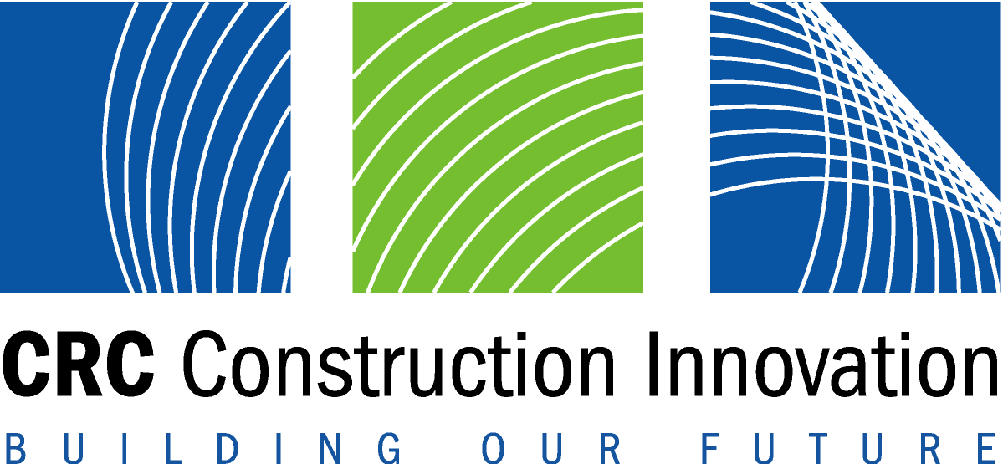
CRC for Construction Innovation
2004 International Conference
25th – 27th October 2004, Gold Coast

Embargo Tuesday October 26 Clients Driving Innovation

Who cares about safety on construction sites?

Construction planning goes 4D

Smarter construction to boost economy

ICALL for excellence in construction

Hot on the heels of the Gold Coast Indy this week, leading built environment practitioners and researchers from around the world will gather at Surfers Paradise for Clients Driving Innovation, an international conference hosted by the Australian Cooperative Research Centre for Construction Innovation.

“Clients have the ability to drive innovation through their project delivery team, their purchasing power, through documentation standards, and developing regulations and codes,” said Construction Innovation CEO, Dr Keith Hampson.

“Property and construction industry clients, designers, constructors and facility managers will be at the conference exchanging ideas and exploring the latest research and industry case studies.”

Conference themes include international innovation, capturing and maintaining client requirements, procurement and risk sharing, health and safety, visualisation and information technology, and innovative asset management.

ICALL for excellence in construction

Ms Janet Holmes a Court, Chair of the John Holland Group, will be an honoured guest and speaker at Clients Driving Innovation dinner tonight. Ms Holmes a Court will launch the International Construction Research Alliance (ICALL).

ICALL brings together leading research organisations with the collective aim of creating world best practice in international construction and property management. The foundation members of ICALL include:
- Centre for Integrated Facility Engineering (CIFE), Stanford University, USA
- Centre Scientifique et Technique du Bâtiment (CSTB), France
- Cooperative Research Centre for Construction Innovation, Australia
- Research Institute for the Built and Human Environment, The University of Salford, UK
- VTT Building and Transport, Finland
Conference keynote Australian and international presenters will also speak on the following topics today:

Who cares about safety on construction sites?
In the construction industry, fatality rates are three times higher and compensation claims double the national workplace average, while injury rates are 50 per cent higher than other sectors, according to Managing Director of the John Holland Group, Mr Bill Wild.

“One has to ask if anyone in the industry cares about occupational health and safety, and it’s fair to say that many in the industry don’t,” said Mr Wild, who will be speaking at Clients Driving Innovation today.

…/more
Mr Wild will look at ‘caring clients’ that stand apart in the requirements they impose on themselves and their contractors.

“They have a determination to set standards on the basis of their own belief in what is right rather than on what is the minimum requirement under the law. They believe that safety is an end in itself, not just good business,” he said.

Contact: Mr Bill Wild, John Holland Group on phone: 03 9934 5290, mobile: 0409 066 702, or
email: bill.wild@jhg.com.au

Construction planning goes 4D
Visual 4D models are valuable construction planning tools and thanks to recent developments are now also cost-effective to build, according to Stanford University Professor Martin Fischer who will be speaking at Clients Driving Innovation today.

“We’ve tested visual 4D models in planning the construction of a hospital, a university building, a commercial building, a Frank Gehry project, and a theme park,” Fischer said.

“These cases have shown that more project stakeholders can understand a construction schedule more quickly and completely with 4D visualisation than with traditional construction management tools.”

Fischer’s research team in California has been working with Australia’s CRC for Construction Innovation in formalising the construction knowledge necessary to build 4D models. They have developed a methodology that guides project planners in generating 4D models from 3D product models and construction programs.

Contact: Professor Martin Fischer, Stanford University on phone: 1 650 725 4649 or email: fischer@ce.stanford.edu

Smarter construction to boost economy
Construction sector innovation can be particularly potent in supporting national economic growth, according to an economic impact modelling study presented by Mr David Campbell from ACIL Tasman at Clients Driving Innovation today.

“Smarter construction feeds through into more competitive businesses across the economy, but a key to success lies with the clients. Their demands for and willingness to back productive innovation, and to use it early, are vital if Australia is to capture the benefits,” Mr Campbell said.

“There are big values from modest productivity gains in the sector. We estimate that a one per cent extra productivity advantage from 2005 to 2020 would be worth around $12 billion in extra value added across the period.”

According to Mr Campbell, this reflects the powerful combination of the size of the sector, the long term nature of the investments being made and the scope for delivering innovations that could be deployed rapidly across much of the sector.

Contact: Mr David Campbell, ACIL Tasman on mobile: 0419 584 824, phone: 02 9958 6644, or email: d.campbell@aciltasman.com.au

Also today, the way forward to create sustainable suburbs (Michael Ambrose, CSIRO MIT); adding $millions to business bottom line with new ways of managing corporate real estate (Clive Warren, UQ); motivating contractors for better project performance (Timothy Rose, CRC Construction Innovation); how changing paradigms in knowledge management can benefit construction industry (Tayyab Maqsood, RMIT University); and developing triple bottom line performance measures for forward-looking property owners (Terry Boyd and Philip Kimmet, QUT).

For the full conference program visit www.2004conference.crcci.info
Media inquiries: Louise Ralph on (m) 0412 814 886 or (e) louise@dragonflyinkOz.com

