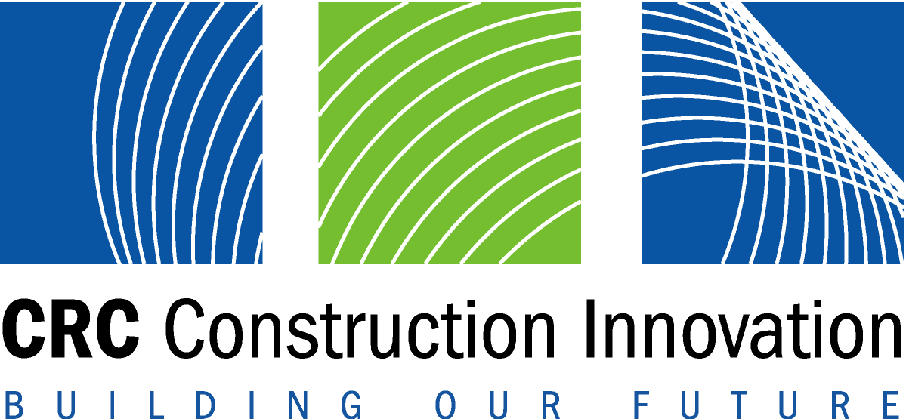
Media Release 28 March 2003

CRC for Construction Innovation already driving innovation in the
Australian Construction Industry

Ethics, Culture, Productivity and Workplace Health and Safety in the Australian Property and Construction industry are significant areas already under applied examination by the Cooperative Research Centre for Construction Innovation (CRC CI).
With headquarters at QUT in Brisbane and 19 industry, government and research partners, the CRC CI was established July 2001 to drive innovation and collaboration in the Australian Construction industry over the long term.
A report written by the Department of Industry, Science and Resources (‘Building Australia’; An Analysis of the Australian Building and Construction Industries, 1999, Department of Industry Science and Resources) and prepared for the National Building and Construction Committee (NatBACC) suggested a cooperative approach between government, industry and stakeholders could work in lifting industry performance.
The CRC CI was subsequently created as a lead agent for change to lead the Australian property and construction industry specifically in the areas of business and industry development, sustainable built assets, and delivery and management of built assets. The CRC CI is driving applied research for real industry outcomes.
Contrary to figures released in some newspaper publications (Thursday 27 March 2003), the broadly defined construction sector contributes a significant 14.4% to Australia’s GDP, rather than the narrower 5 - 7% reported. With over 700 000 people employed in the industry, it is obviously one of the most significant industry contributors to the Australian economy at some A$45 billion/yr, and not $35 billion as reported.
As highlighted through the findings of The Cole Royal Commission, there are issues regarding the adversarial nature of the construction industry. Research in Australia suggests (there are examples in the UK and elsewhere where the industry faces similar problems) one of the root causes of the problems being faced by the industry is the traditional contracting processes, where it all comes down to hard dollar contracting. In an industry that is increasingly competitive, the profit margins have become extremely low while the risks remain high, making it hard to survive.
The Federal and State Governments, researchers and industry have recognised that there is an extraordinarily low level of commitment to R&D in the construction industry (R&D per head in 1996 was US$50 in the US compared to US$14 in Australia), and are together contributing funding and in-kind commitments to the value of A$64 million over seven years to the CRC CI. The CRC CI is tasked with driving change in the industry through innovation and collaboration.
Among the 20 projects currently being undertaken by the CRC CI, some four projects are specifically looking at Ethics, Culture, Productivity and Workplace Health and Safety in the Construction Industry, as described in the project descriptions below:
CRC CI Project: Value in Project Delivery: Facilitating a Change in Culture
This CRC CI team is addressing a specific need identified by some partners to change project delivery systems and to be accountable to the public and its stakeholders. It has been identified that there is a need for further development in terms of organisation culture and attitudes in implementing the novel approaches embodied in relationship contracts. They accept that culture change is a slow process and that it is affected in the first instance by changing individuals’ attitudes. Thus, a change agent, based on a sound understanding of underlying culture and attitudes, is required. The change must be directed towards developing attitudes and culture supportive of relationship contracting.
CRC CI Partners and the Australian Construction Industry will benefit from this research by having access to a definition of those cultural attributes that contribute to success in such projects and then by assisting the implementation of change towards such attitudes within the client’s project delivery team. A change in industry culture will be brought about at the second phase of the research, when the focus shifts from attitudinal change in the client organisation to a culture change in the project team.
CRC CI Project: Ethical Behaviour in the Construction Procurement Process
This CRC CI research focuses on the promotion, management and diffusion of ethical practices in the construction industry and identifies ways in which these factors could encourage widespread cultural change. The team is examining the construction culture and the development of a set of benchmarks against which the ethical performance of the construction industry participants can be gauged. The research will examine the significant differences between culture in regard to ethical performance of individuals and firms in the construction sector specifically in terms of organisational make-up, use of codes of practice, and a range of situational characteristics including organisational focus.
CRC CI Partners and the Australian Construction Industry will benefit from this research through access to a framework for cultural change based on the following cultural attributes:
- A flexible organisational structure grounded on ethics
- A managerial commitment to ethics
- A diverse human resource profile
- A system of communication using ethical practices
- An identifiable, open and dynamic culture
- A system of setting of cost performance goals and a system of cost management that promotes business ethics and innovation
- Strategic relationships with clients, financiers, suppliers and subcontractors founded on business ethics.

Benefits of this research for the Construction industry are to foster and promote the sound practice of business ethics; develop new perspectives on future development of ethical practices and to improve organisational efficiency through the adoption of ethical practices. A further outcome is a better understanding of the business ethics of other organisations in the supply chain such as owners, suppliers, governments, and customers.
CRC CI Project: Linking Best-Value Procurement to Outcome Performance Indicators
In this project, the CRC CI team is linking the development of a standard set of tender evaluation criteria based on best-value (to which individual clients can attach their own weightings) with definition of Outcomes Performance Indicators (OPI) that would be required to be reported upon at the completion of projects. This would provide an important link between the selection criteria and the means to evaluate how the project succeeded on a broader set of success criteria. Currently, the standard project control indicators such as time, cost and OHS tend to be more concerned with gathering lagging indicators for project control monitoring and reporting systems.
The benefits of this project to CRC CI partners and the Australian Construction Industry is that it provides a set of direct cause and effect indicators that can be used as part of improved post project evaluation and assist in gathering a lessons learned knowledge base. Further, the OPIs identified could be operationalised for use as a broader balanced scorecard approach to performance measurement thus providing leading indicators of likely success or impending problems.
CRC CI Project: Workplace Health and Safety in an International Context
This is a new CRC CI project which is looking at what the barriers to safety are, including the small subcontract market, cultural change, formwork and scaffolding accidents and a 20% increase in price.
Project parameters may be defined as:
- Determining levels of performance safety by defining international standards based within a context of culture, systems, behaviour, and intention.
- Identifying ways the construction industry can move to zero incidences and beyond
- Embedding the Workplace Health and Safety outcomes of this research into the mainstream construction industry.

ENDS
CRC for Construction Innovation is a collaboration involving 19 industry, government and research partners and has been made possible through a $14 million Federal Government grant through the CRC Program complementing $50 million in other industry, research and other government funding.
CRC CI partners include: Arup Australasia, Australian Building Codes Board, Bovis Lend Lease, Building Commission, CSIRO, DEM, John Holland, Kennards Hire, Queensland Department of Main Roads, Queensland Department of Public Works, Queensland State Development, Queensland University of Technology, Rider Hunt, RMIT, Springfield, University of Newcastle, University of Sydney, University of Western Sydney and Woods Bagot.

More information: Dr Keith Hampson, CEO, CRC CI
T: 07 38641393 E: enquiries@construction-innovation.info.

Mr Don Allan, Deputy Program Director, Business and Industry Development, CRC CI
T: 07-3224-5487 E: don.allan@publicworks.qld.gov.au

Media assistance: Kate Finlayson, Communications Officer, CRC CI
T: 07 3864 9295 M: 0417 873 813
E: k.finlayson@construction-innovation.info

