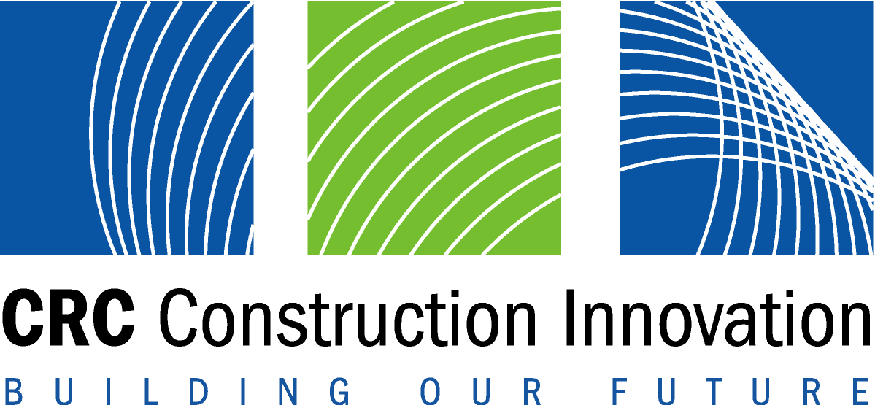



Making Innovation Happen on Construction Projects
You are cordially invited to the launch of the
2005 BRITE Case Studies of Innovative Projects
Date: Wednesday 2 November, 2005
Time: Speakers: 5:00 – 6.00 pm Refreshments 6:00-7:30 Registration from 4:30
Venue: The Auditorium
111 George Street, Brisbane
Cost: The event is free of charge but seats are limited, so register early!
To Register: Email m.coillet@qut.edu.au Phone Michelle Coillet on (07) 3864 9146
Innovation is the key to better productivity and profitability.
Come and hear contractors, consultants, clients and suppliers describe how they make innovation happen on construction projects.
The talks cover new contracting methods, water management, 3D CAD, toxic waste disposal, long span roofs, air conditioning and pavement technologies.
The speakers are:
Michael Deare Chief Executive, South Australian Cricket Association
Max Smith Deputy Director General Works, Qld Dept Public Works
Phillip Marsh Director, Marsh Civil Contractors
Scott Bird Managing Director, ENV Australia
Rebecca Hoskin Manager Capital & Facilities, Dept of the Premier & Cabinet – Arts SA
Jeremy Harding Business Development Manager, s2 Corporation
Garry Callinan Managing Director, Ecoflex Civil Constructions
Diana Kureen (Former) Bushland Environment Officer, Hunters Hill Council
Join 200 of your industry colleagues at this excellent networking opportunity.
Drinks and savouries provided.

